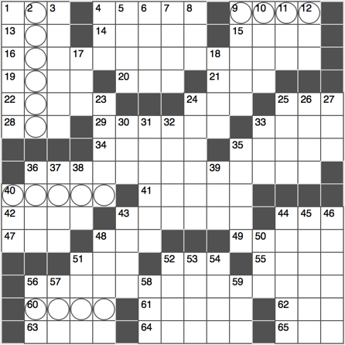**ACROSS**

1. Nonverbal communications sys.

4. Pungent, as fumes

9. Last testament

13. April’s second?

14. Simba’s sounds

15. Suited to serve

16. Possible incidents on 36-Across

19. Tonight Show’s former host

20. Hand made soap ingredient

21. Commercials, for instance

22. “____ at your own risk”

24. “The Big Bang Theory” network

25. Sault ____ Marie

28. Way of Lao-Tze

29. Throat danglers

33. Lean

34. Nation between Togo and Nigeria

35. Moaning Myrtle’s abode, in Harry Potter and the Chamber of Secrets

36. Time of pranks and hijinks, or a hint to 16- and 56-Across

40. Site for a sprint

41. Sharpshooter Oakley

42. Verdi opera set in Egypt

43. Face, colloquially

44. Man’s name that’s also an alphabet run

47. Dorm deputies, abbr.

48. Neither’s go-with

49. Stuffy site?

51. ____ Aviv

52. Fake head of hair

55. Scrutinize, with “over”

56. Possible antic on 36-Across

60. Year-end high school formal

61. Deadly west African virus

62. Small child

63. Stare unashamedly

64. Sci-Fi’s Vader

65. Lead-in to Balls or Caps

**DOWN**

1. In-browser program
2. Tennis player Williams
3. Sloped-roof shelter
4. State-of-the-____
5. Be windy?
6. Risqué
7. “____ Dies” (requiem hymn)
8. Broadband connection type: abbr.
9. Links star Tiger
10. Pen fillers
11. Confederate General Robert
12. ____ Vegas

17. Miler Sebastian

18. Uppercut alternatives

23. Color cube pioneer

24. Religious laws

25. Mets’ old home

26. Itsy

27. Terminus

30. Speed with direction, abbr.

31. Rigged

32. “____ and tigers and bears, oh my!”

33. “We’re not sure yet,” on a schedule

35. They might need a manual

36. Diva’s performance

37. Part of a goalie’s gear

38. Color TV pioneer

39. Fib

40. Sticky road stuff

43. City on der Rhein

44. Pig noses

45. Activate, as a light switch

46. “Somebody That I ____ Know” (2011 Gotye song)

48. Self-description after a lifestyle change

50. Opportunity to take stock, for short?

51. Hammer or drill

52. Where the Sky and the Sun collide, for short?

53. Composer Stravinsky

54. Who is John ____?

56. Navy non-com

57. Partner of sm. or med.

58. Roadside bomb, briefly

59. “Go team!”